
FATIMA JINNAH WOMEN UNIVERSITY
RAWALPINDI
Department Of Software Engineering

Cloud Computing Lab

Saira Ejaz [2023-BSE-057]

Section: 5-B

LAB NO 6
Lab Task:
Task 1 – Switch to root with su - and back to a normal user
- Set a root password (Ubuntu root is disabled by default; this enables su - temporarily for the lab):
sudo passwd root
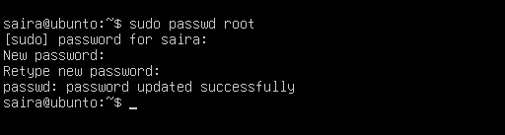
# Enter a temporary root password for the lab
- Switch to root and verify:
su -
whoami
id
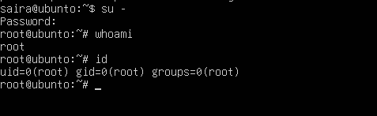
- Switch back to your normal user:
exit
whoami
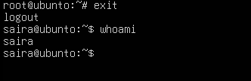
Task 2 – Create user tom and verify in passwd/group/shadow
Goal: Create a user named tom, then verify the account in system files.
- Create user tom (interactive, sets password and home directory):
sudo adduser tom
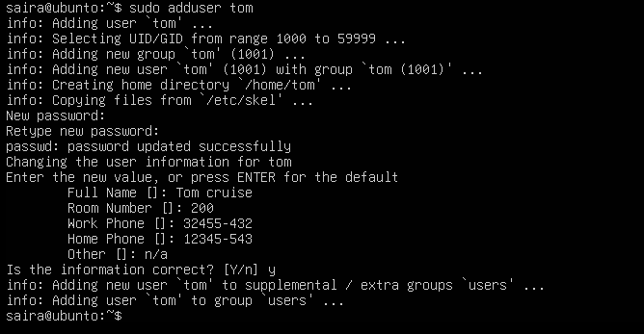
- Verify tom in system files (view and visually confirm presence):
cat /etc/passwd
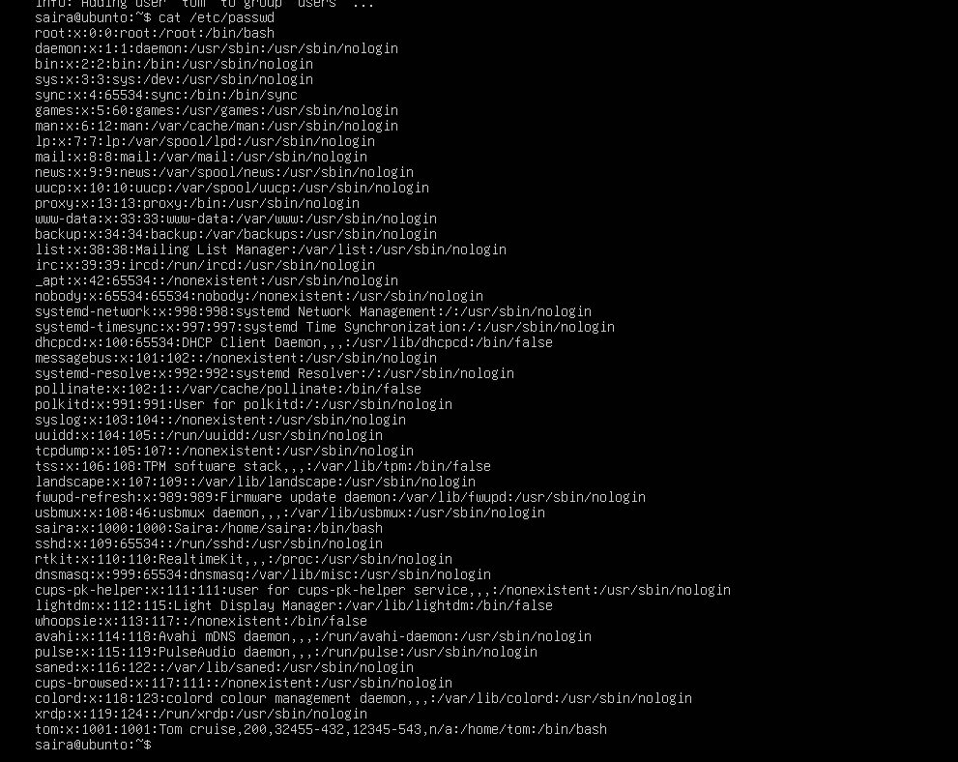
cat /etc/group
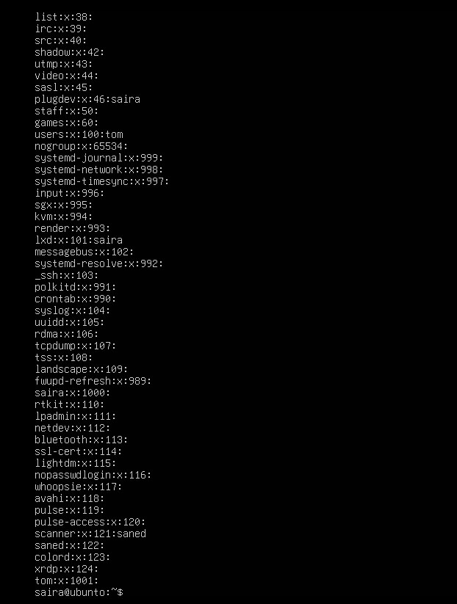
sudo cat /etc/shadow
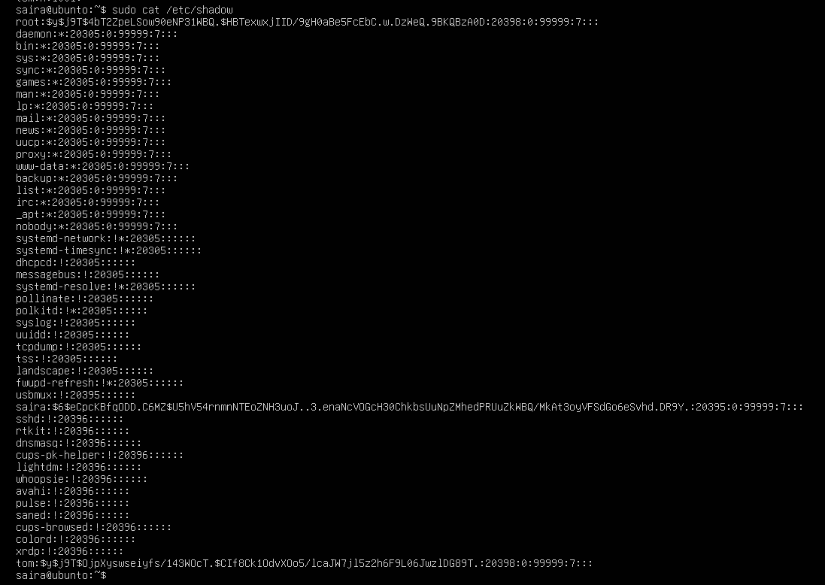
Task 3 – Create groups; change tom’s primary and secondary groups
Goal: Create groups developer, devops, and designer. Change tom’s primary group and manage secondary groups.
- Create groups and verify by viewing /etc/group (visually confirm entries exist):
sudo groupadd developer
sudo groupadd devops
sudo groupadd designer
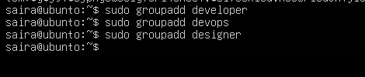
cat /etc/group
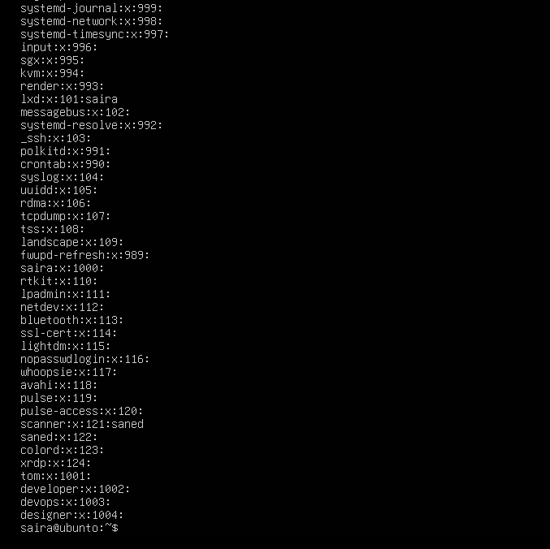
- Change tom’s primary group to designer and verify:
sudo usermod -g designer tom
id tom
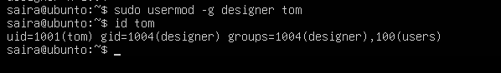
- Add secondary groups developer and devops to tom and verify:
sudo usermod -aG developer,devops tom
id tom
groups tom
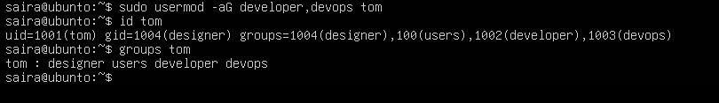
- Replace all secondary groups so only tom (user’s own group) remains and verify:
sudo usermod -G tom tom
id tom
groups tom
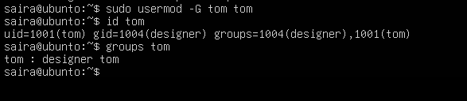
Task 4 – Create/delete users (Jerry, Scooby) and groups (jolly, anime)
Goal: Create users using both adduser and useradd, demonstrate login/password/home directory differences, then delete users/groups.
- Create users:
sudo adduser Jerry
sudo useradd Scooby
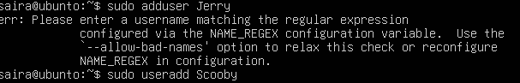
- Try to log in as Scooby immediately (expected authentication failure because there is no password yet):
su – Scooby
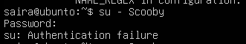
- Set a password for Scooby:
sudo passwd Scooby
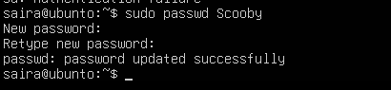
- Try logging in as Scooby again (home directory still missing; expect a message such as “No directory, logging in with HOME=/”):
su – Scooby
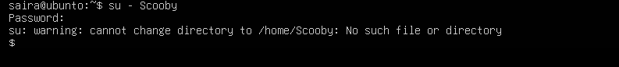
- Show that Scooby’s home directory does not exist yet and what /etc/passwd says:
exit
cat /etc/passwd
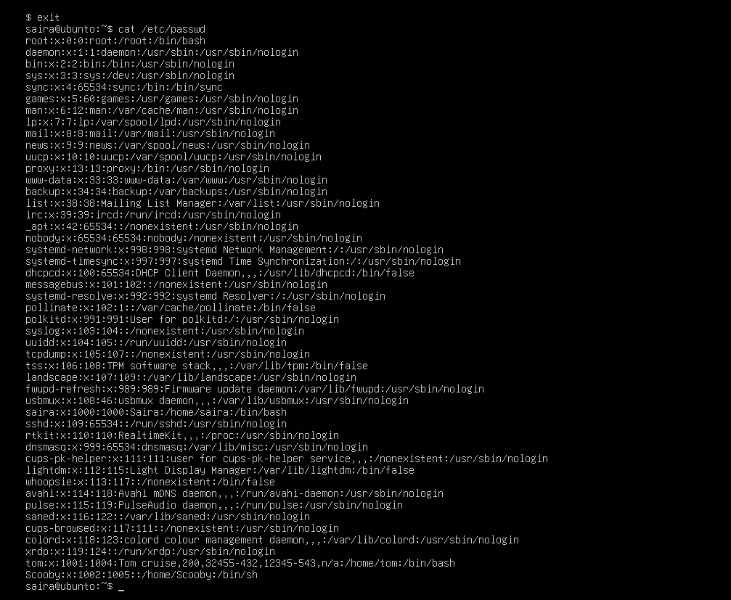
ls -ld /home/Scooby
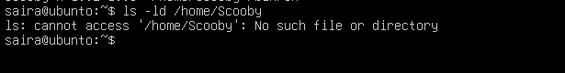
- Manually create Scooby’s home directory and set proper ownership and permissions:
sudo mkdir -p /home/Scooby
sudo chown Scooby:Scooby /home/Scooby
sudo chmod 750 /home/Scooby
ls -ld /home/Scooby
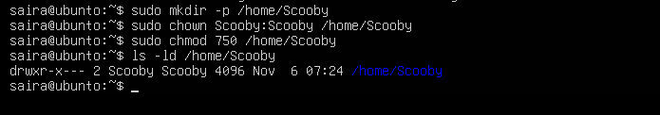
- Log in as Scooby again and verify you land in the correct home directory:
su - Scooby
pwd
ls -la
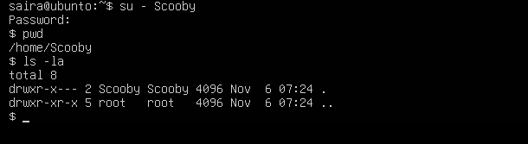
- Verify users in system files and observe shell of Scooby:
exit
cat /etc/passwd
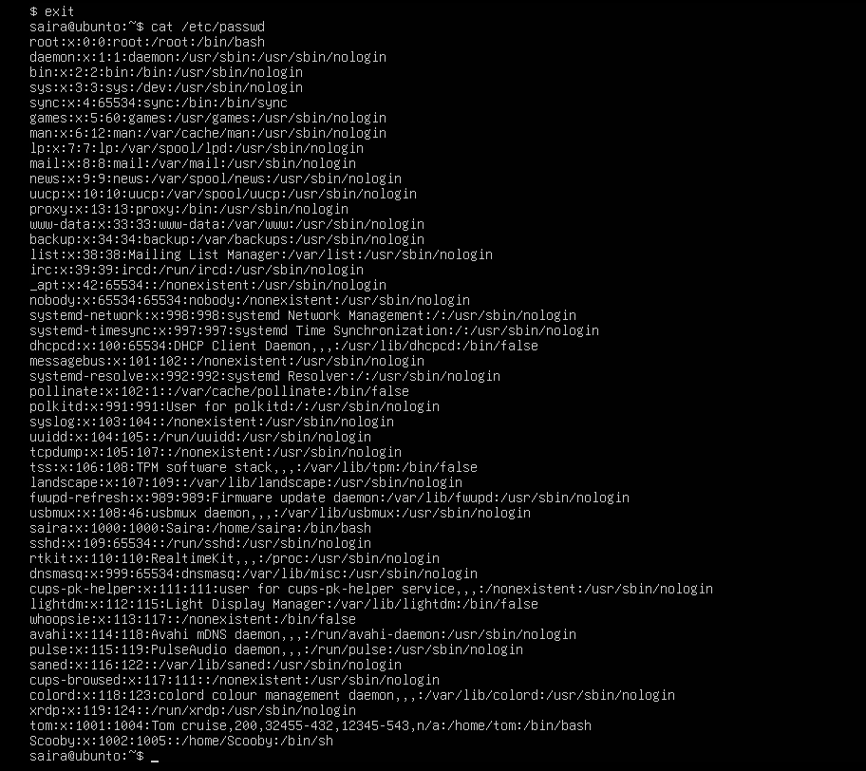
- Change the shell from /bin/sh to /bin/bash
sudo usermod -s /bin/bash Scooby
su – Scooby
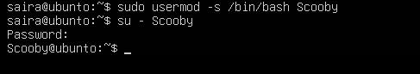
- Create groups:
sudo addgroup jolly
sudo groupadd anime

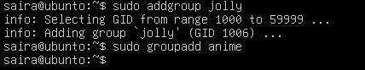
- Verify groups:
cat /etc/group
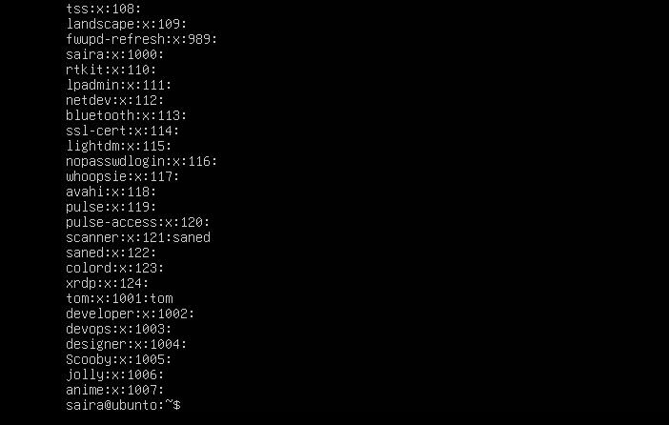
- Delete groups and users:
sudo delgroup jolly
sudo groupdel anime
cat /etc/group
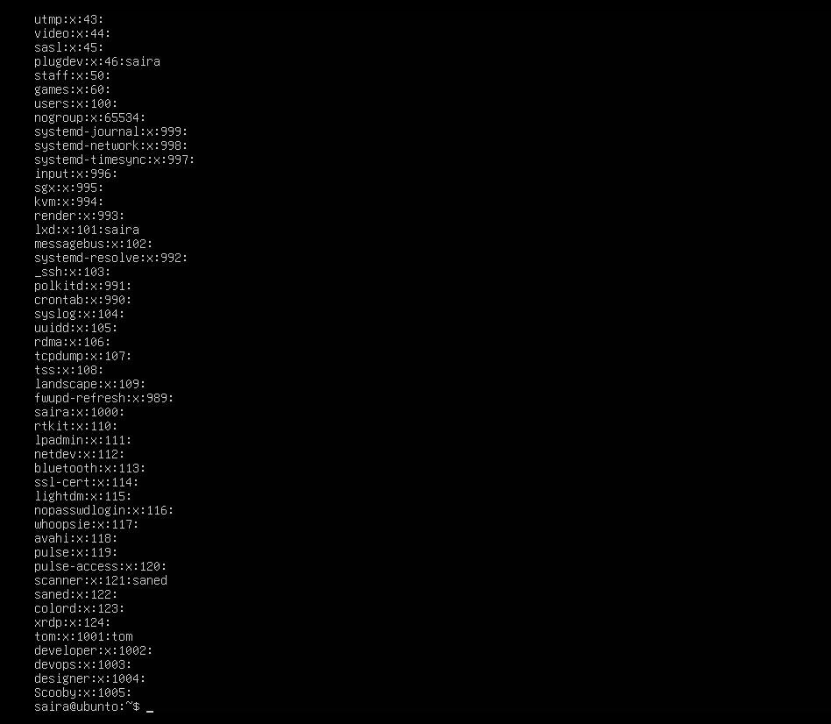
sudo deluser --remove-home Jerry
sudo userdel -r Scooby
cat /etc/passwd

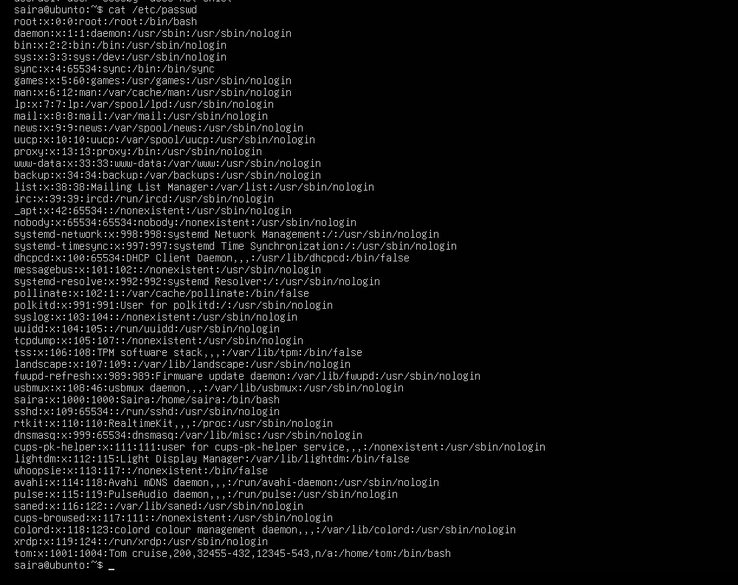
Task 5 – Create user Student; create files; set owner/group; identify file types
- Create Student:
sudo adduser Student
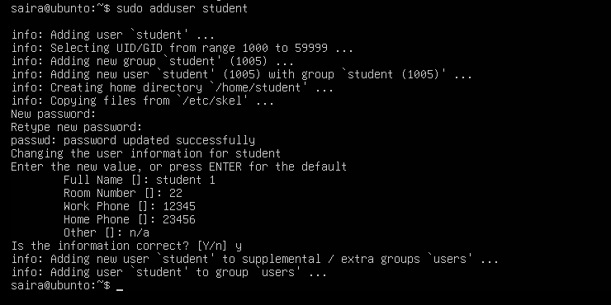
- Switch to Student and create files:
su - Student
touch file1
mkdir -p dir1
touch dir1/file2
ls -l
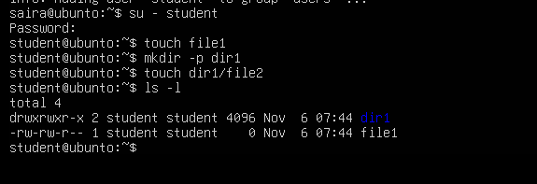
- Change owner then group for file1 (separate commands):
sudo chown tom file1
ls -l file1
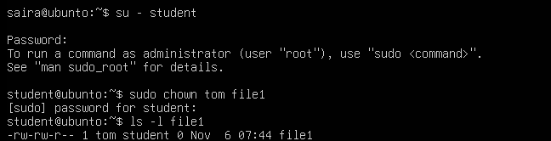
sudo chgrp devops file1
ls -l file1
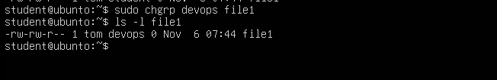
- Identify files/directories and show /dev/null:
ls -l
ls -l dir1
ls -l /dev/null
file file1 dir1 /dev/null
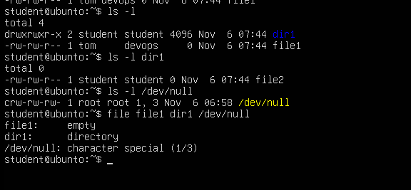
- Exit Student:
exit
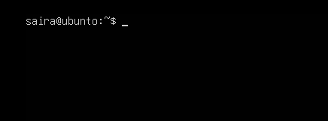
Task 6 – Change permissions using symbolic mode
- Ensure Student and file present:
su - Student
cd ~
ls -l file1
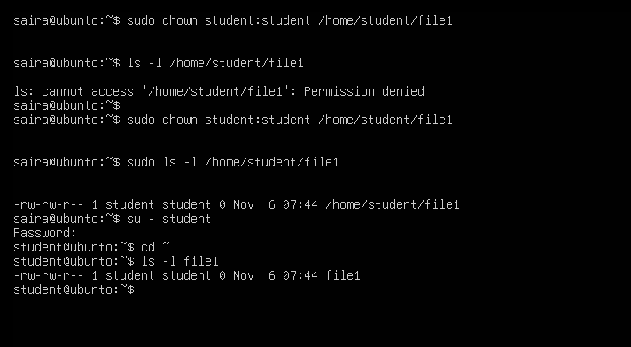
- Remove all permissions:
chmod -rwx file1
ls -l file1
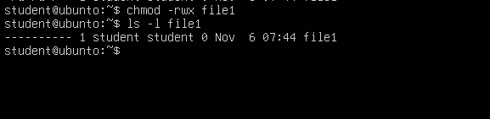
- Add read to all:
chmod +r file1
ls -l file1
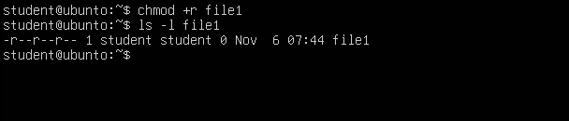
- Add execute to user:
chmod u+x file1
ls -l file1
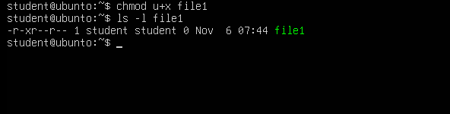
- Add write to user and group:
chmod ug+w file1
ls -l file1
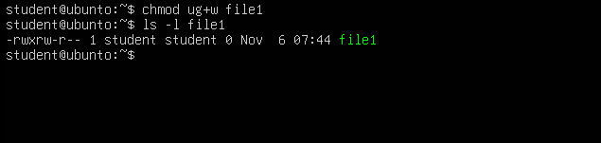
- Remove all permissions (explicit):
chmod ugo-rwx file1
ls -l file1
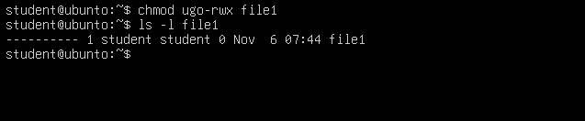
Task 7 – Change permissions using “set” symbolic form (u= g= o=)
Ensure you are Student:
su - Student
cd ~
ls -l file1
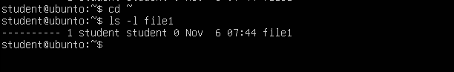
- Set all to rwx:
chmod u=rwx,g=rwx,o=rwx file1
ls -l file1
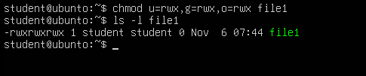
- Remove execute from group and others:
chmod g=rw,o=rw file1
ls -l file1
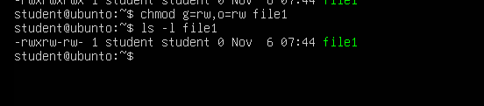
- Remove all permissions:
chmod u=,g=,o= file1
ls -l file1
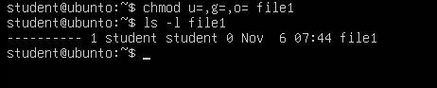

Task 8 – Change permissions using numeric (octal) mode
Ensure you are Student:
su - Student
cd ~
ls -l file1

Run each command and capture screenshot after each ls:

chmod 777 file1
ls -l file1
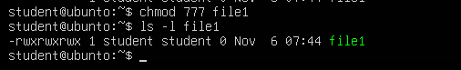

chmod 700 file1
ls -l file1
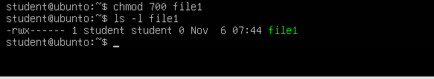

chmod 744 file1
ls -l file1
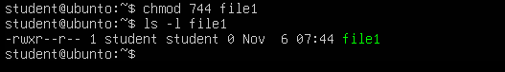

chmod 640 file1
ls -l file1
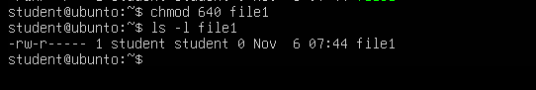

chmod 664 file1
ls -l file1
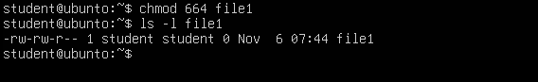

chmod 775 file1
ls -l file1
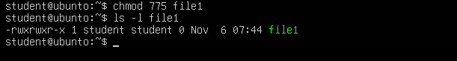

chmod 750 file1
ls -l file1
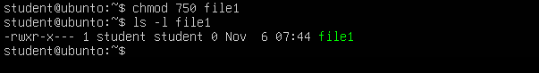
Task 9 – Practice pipes, pagers, grep, and redirects with /var/log/syslog
- less:
sudo cat /var/log/syslog | less
# quit q
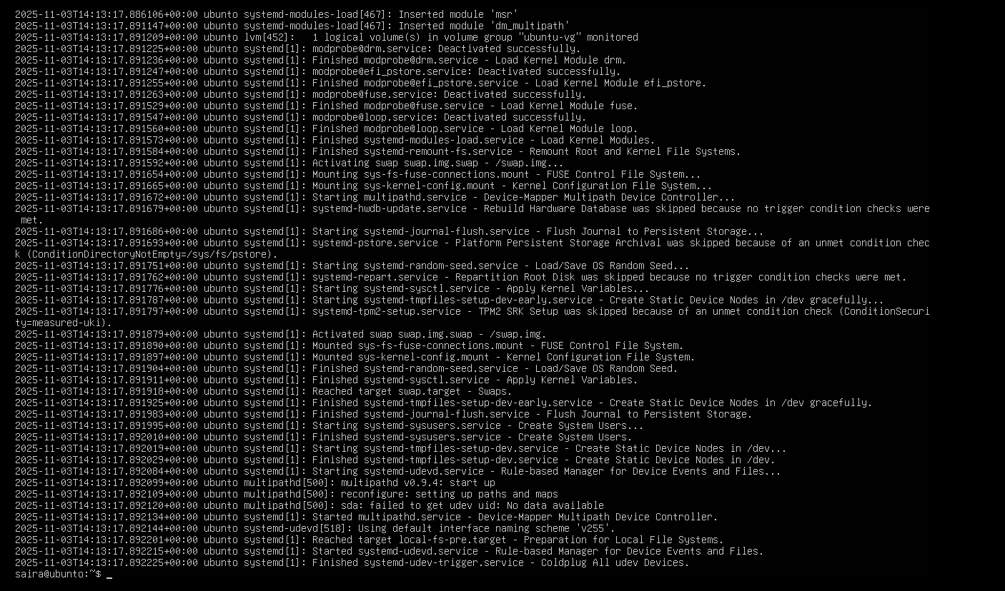
- more:
sudo cat /var/log/syslog | more
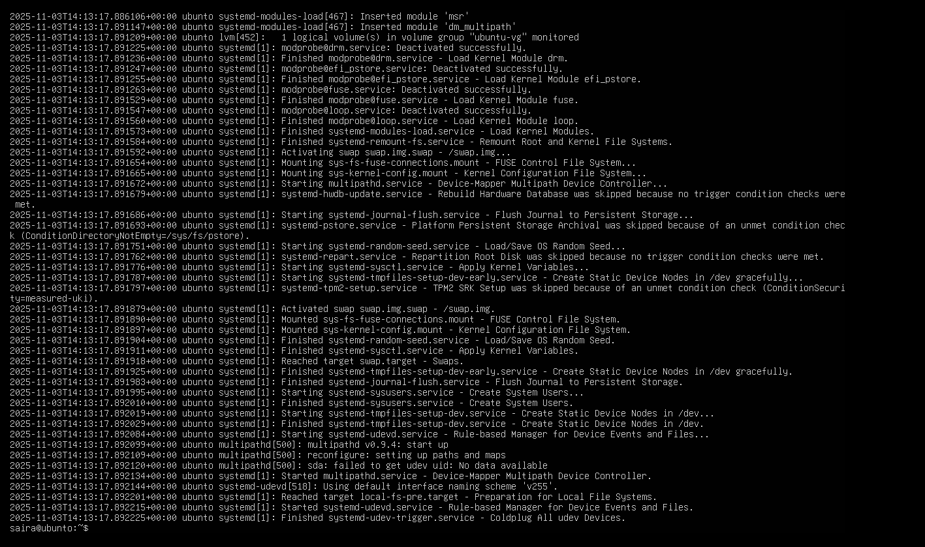
- grep failures/errors:
sudo grep -E 'fail|error' /var/log/syslog | head
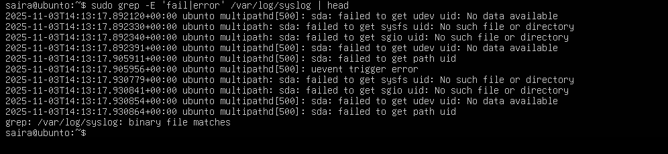
- redirect:
sudo grep -i systemd /var/log/syslog > ~/syslog_systemd.txt
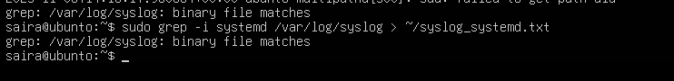
- append:
sudo grep -i network /var/log/syslog >> ~/syslog_systemd.txt
cat ~/syslog_systemd.txt
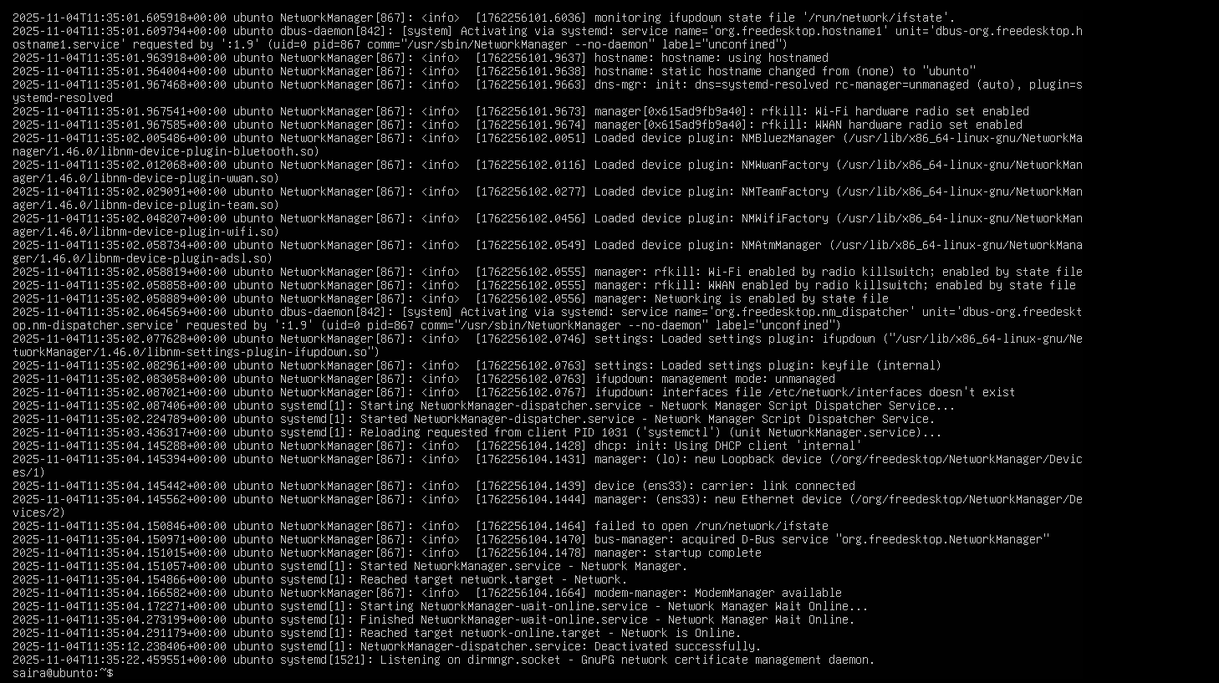
Alternative (journalctl) if needed:
sudo journalctl | less
sudo journalctl -u systemd | grep -i error > ~/journal_errors.txt
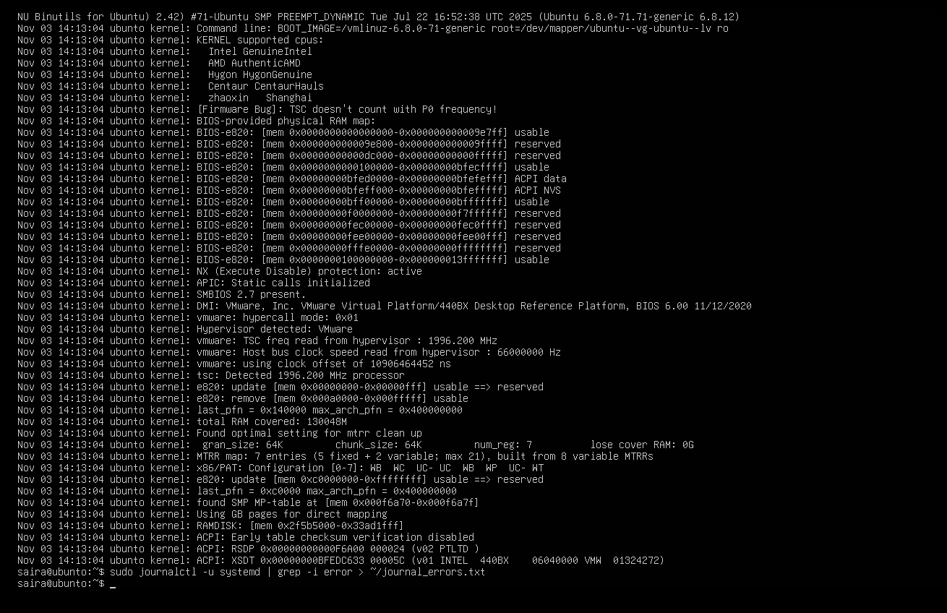
Task 10 – Script setup.sh – variables, command substitution, file/dir checks, permissions (use vim)
Start in your Student home directory (recommended).
- Include bash shebang
- Code to add (enter in vim as the first line of the file):
#!/bin/bash
- Steps:
  - vim setup.sh → add the shebang line → save and quit
  - chmod +x setup.sh
  - ./setup.sh

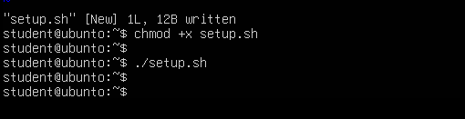
Step B2 — Append var1
- Open setup.sh again:
vim setup.sh
- Press i and go to new line under the shebang, paste:
# Define and show var1
var1="Hello from Lab 6"
echo "var1: $var1"
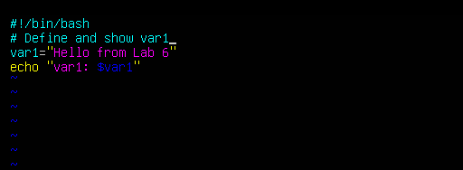
- Save and quit:
ESC
:wq
- Run the script:
./setup.sh
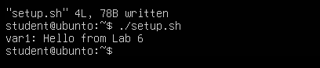
Step B3 — Append ls -l variable
vim setup.sh
Insert below previous code:
# Save ls -l to variable and display
allFiles="$(ls -l)"
echo "allFiles (ls -l):"
echo "$allFiles"
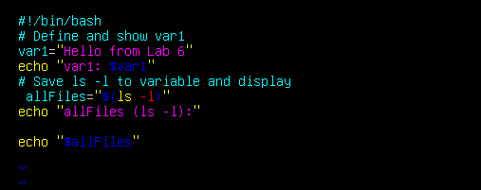
Run:
./setup.sh
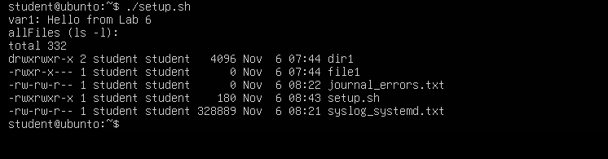
Step B4 — Directory check
vim setup.sh
Add:
# Directory check
if [ -d "dir1" ]; then
echo "Directory dir1 exists."
else
echo "Directory dir1 does not exist. Creating..."
mkdir -p "dir1"
echo "Directory dir1 created."
Fi
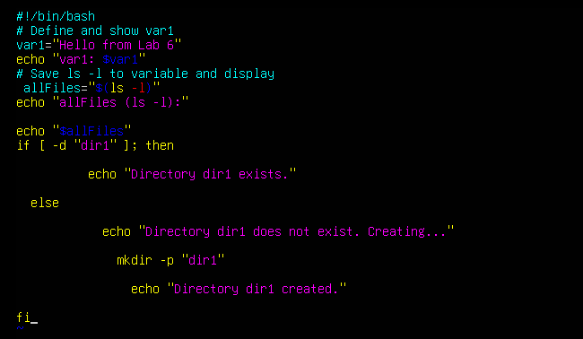
Save & Run:
./setup.sh
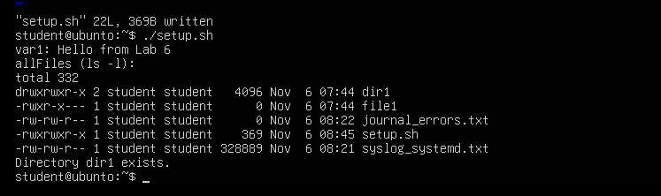
Step B5 — File check
vim setup.sh
Add:
# File check
if [ -f "dir1/file2" ]; then
echo "file2 already exists."
else
echo "file2 does not exist. Creating..."
touch "dir1/file2"
chmod a-rwx "dir1/file2"
echo "file2 created."
Fi
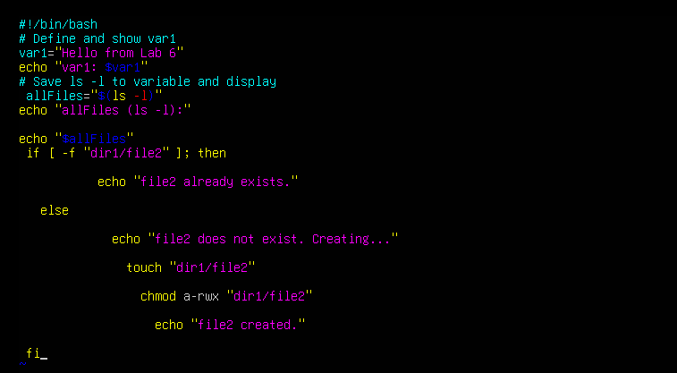
Save & Run:
./setup.sh
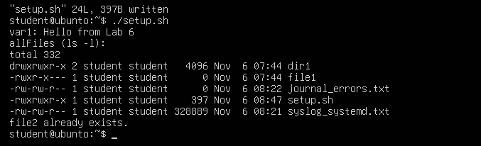
Step B6 — Permission checks
vim setup.sh
Add:
# Permission checks for dir1/file2 (user permissions)
f="dir1/file2"
if [ ! -r "$f" ]; then
echo "Read permission missing; granting to user..."
chmod u+r "$f"
fi

if [ ! -w "$f" ]; then
echo "Write permission missing; granting to user..."
chmod u+w "$f"
fi

if [ ! -x "$f" ]; then
echo "Execute permission missing; granting to user..."
chmod u+x "$f"
fi

echo "Final permissions for $f:"
ls -l "$f"
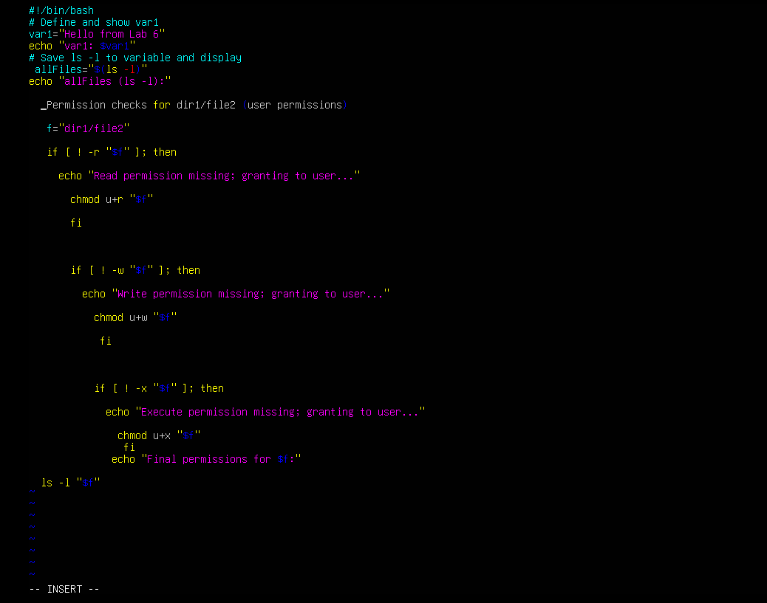
Save & Run:
./setup.sh
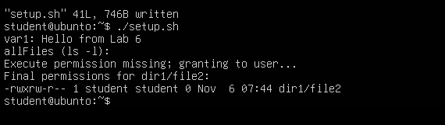
Task 11 – Script setup.sh – argument comparisons (eq, ne, gt, lt, ge, le) and string checks

STEP B0 — Create File and Define Variables
Open the file:
vim setup.sh
Insert exactly this inside:
#!/bin/bash
num=$1
str=$2
Save and exit:
:wq
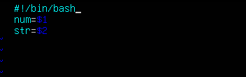
Make executable:
chmod +x setup.sh
Run example:
./setup.sh 10 Student
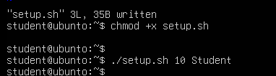
STEP B1 — Add -eq (equal)
Open for edit:
vim setup.sh
Append this at the bottom:
if [ "$num" -eq 10 ]; then
echo "$num is equal to 10 (-eq)."
else
echo "$num is NOT equal to 10 (-eq)."
fi
Save & exit: :wq
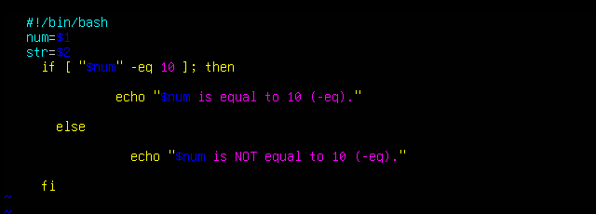
Run:
./setup.sh 10 Student
./setup.sh 7 Student
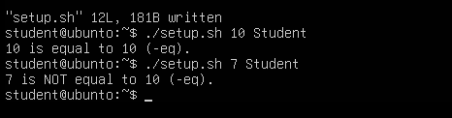
STEP B2 — Add -ne (not equal)
Append:
if [ "$num" -ne 10 ]; then
echo "$num is not equal to 10 (-ne)."
else
echo "$num is equal to 10 (-ne false)."
Fi
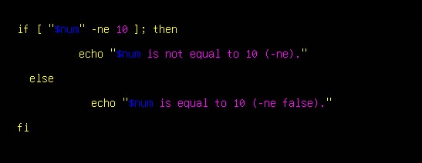
Run:
./setup.sh 7 Student
./setup.sh 10 Student
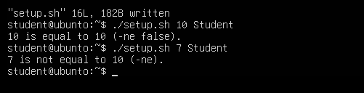
STEP B3 — Add -gt (greater than)
Append:
if [ "$num" -gt 10 ]; then
echo "$num is greater than 10 (-gt)."
else
echo "$num is NOT greater than 10 (-gt)."
Fi
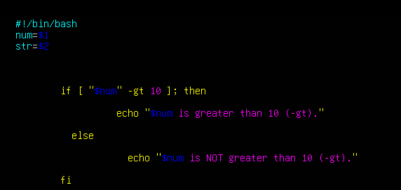
Run:
./setup.sh 12 Student
./setup.sh 9 Student
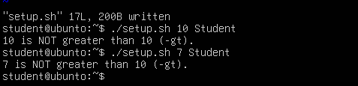
STEP B4 — Add -lt (less than)
Append:
if [ "$num" -lt 10 ]; then
echo "$num is less than 10 (-lt)."
else
echo "$num is NOT less than 10 (-lt)."
Fi
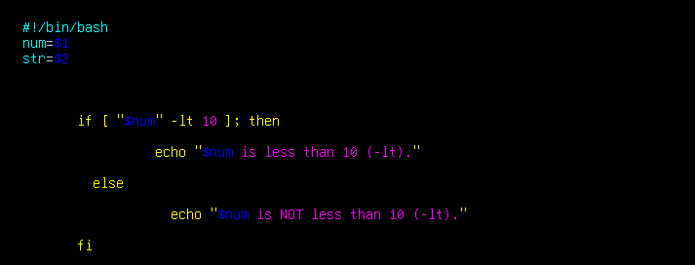
Run:
./setup.sh 5 Student
./setup.sh 11 Student
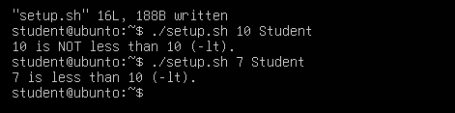
STEP B5 — Add -ge (≥)
Append:
if [ "$num" -ge 10 ]; then
echo "$num is greater than or equal to 10 (-ge)."
else
echo "$num is NOT greater than or equal to 10 (-ge)."
Fi
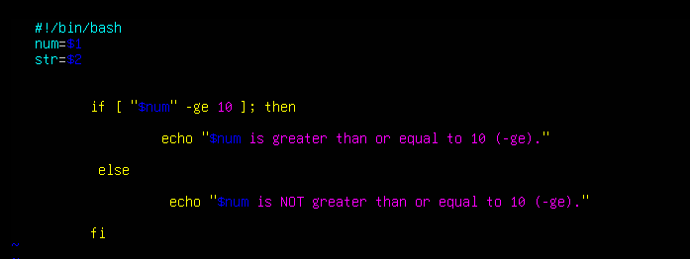
Run:
./setup.sh 10 Student
./setup.sh 8 Student
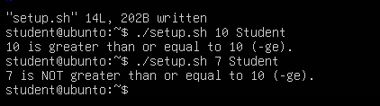
STEP B6 — Add -le (≤)
Append:
if [ "$num" -le 10 ]; then
echo "$num is less than or equal to 10 (-le)."
else
echo "$num is NOT less than or equal to 10 (-le)."
Fi
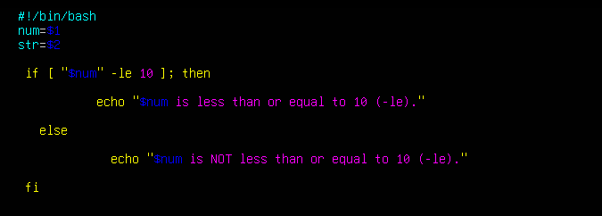
Run:
./setup.sh 10 Student
./setup.sh 12 Student
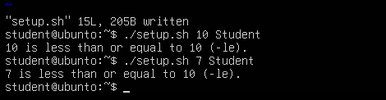
STEP B7 — String Equality =
Append:
if [ "$str" = "Student" ]; then
echo "Second argument equals 'Student' ( = )."
else
echo "Second argument does NOT equal 'Student' ( = )."
Fi
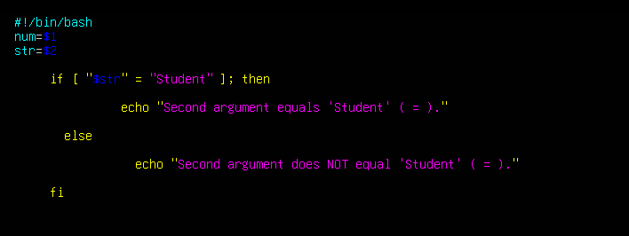
Run:
./setup.sh 10 Student
./setup.sh 10 Test
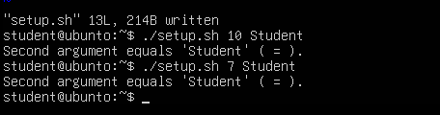
STEP B8 — String Inequality !=
Append:
if [ "$str" != "Student" ]; then
echo "Second argument is not equal to 'Student' ( != )."
else
echo "Second argument equals 'Student' ( != false)."
Fi
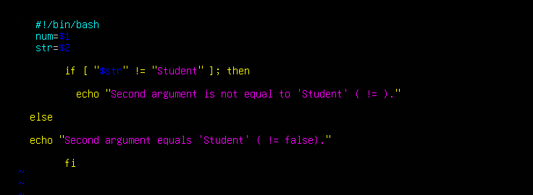
Run:
./setup.sh 10 Test
./setup.sh 10 Student
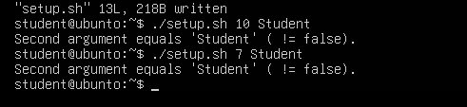
STEP B9 — Check if second argument is empty -z
Append:
if [ -z "$str" ]; then
echo "Second argument is empty (zero-length)."
else
echo "Second argument is not empty."
Fi
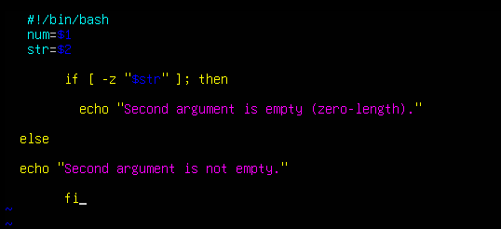
Run:
./setup.sh 10
./setup.sh 10 Student
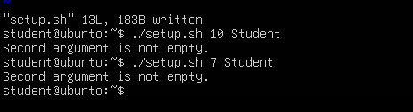
Combined:
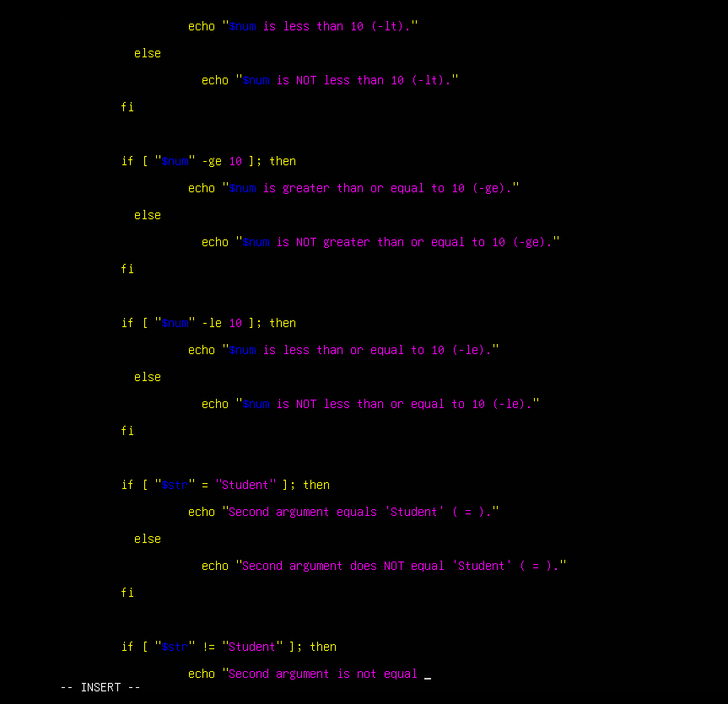
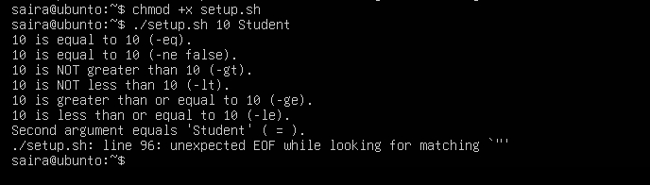
Task 12 – Script setup.sh – print all arguments with a for loop
- Create the script with shebang and basic structure
- Open vim and overwrite setup.sh:
vim setup.sh
- Insert these lines (first step — shebang and a short comment):
#!/bin/bash
# Script to demonstrate printing all user-entered arguments using $*
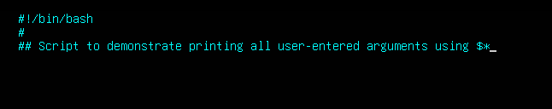
- Save and quit (:wq)
- Append the for loop using $* and print each argument
- Re-open setup.sh in vim and append the following lines:
# Print all arguments using $*
echo "Printing all arguments using \$*:"
for arg in $*; do
echo "Argument: $arg"
done
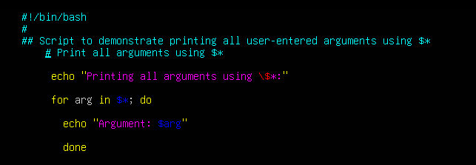
- Save and quit (:wq)
- Make the script executable and run it with example arguments:
chmod +x setup.sh
./setup.sh one "two words" three
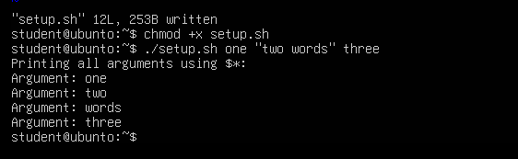
Task 13 – Script setup.sh – while loop summation and functions
- Add the shebang line
- Open vim and overwrite setup.sh with the shebang line:
#!/bin/bash
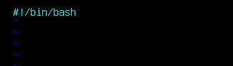
- Save and quit (:wq)
- Make executable and run (no output expected):
chmod +x setup.sh
./setup.sh
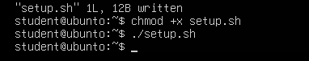
- Add the while-loop summation (interactive)
- Re-open setup.sh in vim and append the while-loop:
# While-loop summation (interactive)
sum=0
while true; do
read -p "Enter a number (or 'q' to quit): " input
if [ "$input" = "q" ]; then
break
fi

sum=$((sum + input))
echo "Total Score: $sum"
done
echo "Final total: $sum"
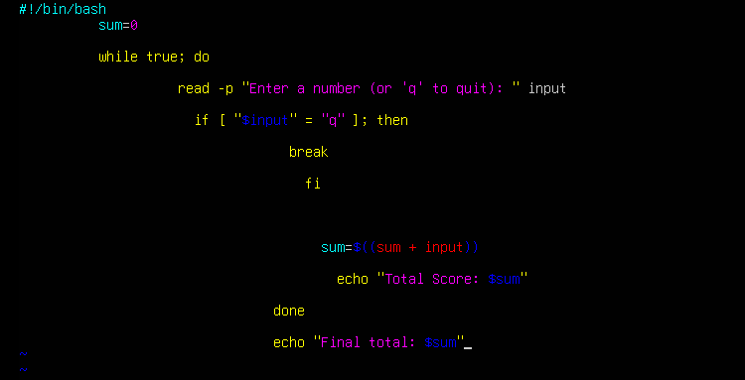
- Save and quit (:wq)
- Run the script and demonstrate a short session (example): enter 5, then 7, then q
./setup.sh
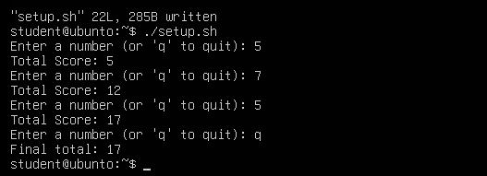
- Add the interactive summation function and demonstrate it
- Re-open setup.sh in vim and append the function sum_two() which contains its own interactive while-loop:
# Function to accumulate scores interactively
sum_two() {
sum=0
while true; do
read -p "Enter a number (or 'q' to quit): " input
if [ "$input" = "q" ]; then
break
fi

sum=$((sum + input))
echo "Total Score: $sum"
done
echo "Function final total: $sum"
}

# Demonstrate the function
echo "Now calling sum_two function:"
sum_two
- Save and quit (:wq)
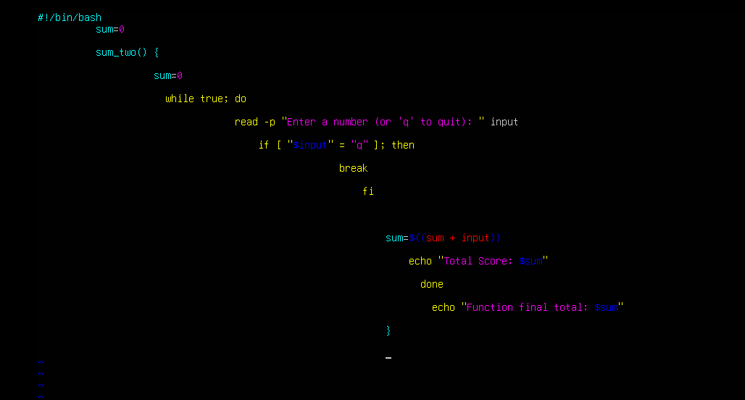
./setup.sh
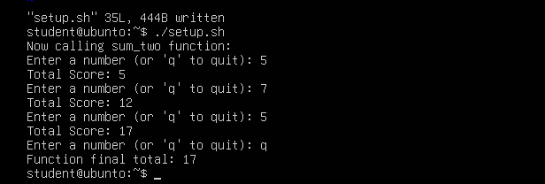
- Add a function that takes two numeric arguments, sums them, and returns the result (echo)
# Function that sums two arguments and returns the result
sum_args() {
a=$1
b=$2
return $((a + b))
}

# Demonstrate sum_args function
echo "Now demonstrating sum_args function:"
sum_args 3 4
result=$?
echo "sum_args(3,4) returned: $result"
- Save and quit (:wq)
- Run the script and capture the demonstration output:
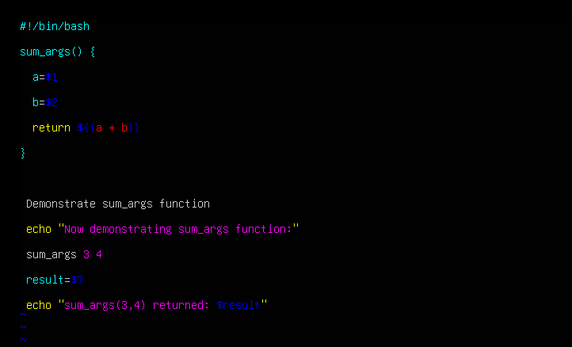
chmod +x setup.sh
./setup.sh
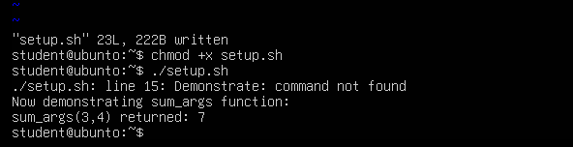
Task 14 – Codespaces GUI — fork repo, run start-desktop.sh, open VNC, stop GUI
Steps:
- Fork the repository to your GitHub account
- Open the repo URL in your browser:
  - Ubuntu Machine
- Click "Fork" (top-right) and fork it to your account.
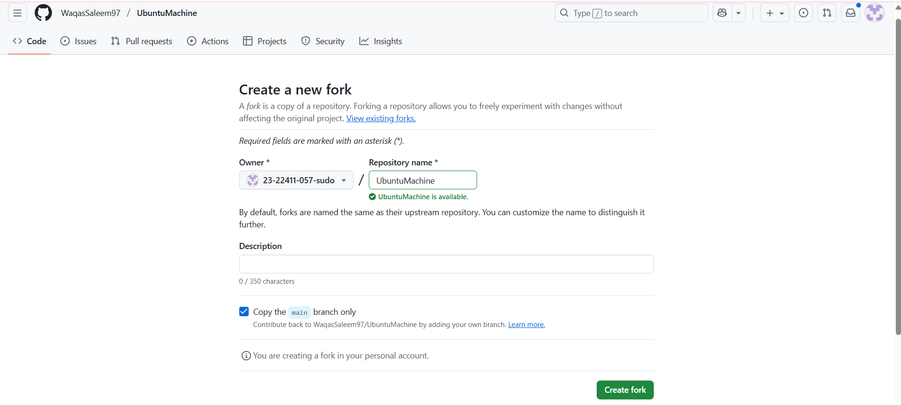

- Open a Codespace on your fork
- In your forked repository on GitHub, click the green "Code" button → "Open with Codespaces" → "Create codespace on main" (or appropriate branch).
- Wait for the Codespace to initialize.
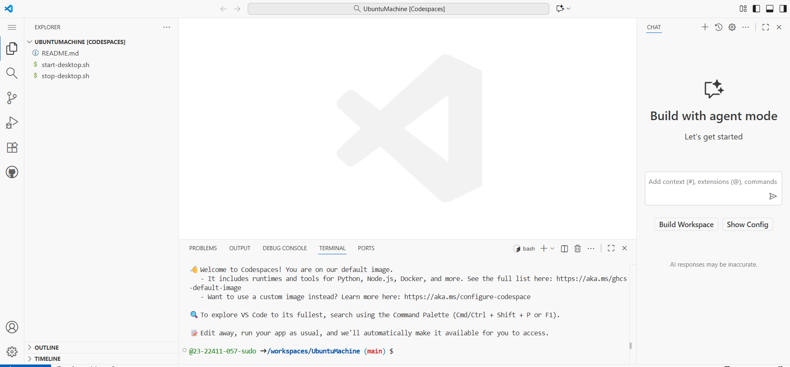
- Verify the start script is present and executable (capture evidence)
- In the Codespace terminal list files in the repo root and show the start script and stop script exist:
ls -l start-desktop.sh stop-desktop.sh
- If not executable, make it executable:
chmod +x start-desktop.sh stop-desktop.sh
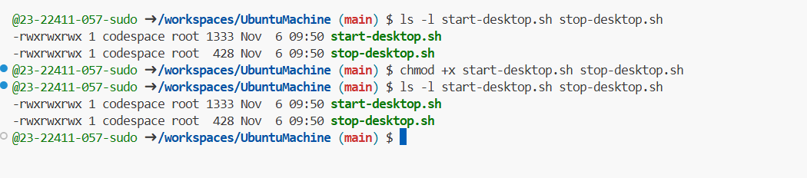
- Run the start script inside the Codespace terminal
- In the Codespace terminal run:
# Ensure the start script is executable
chmod +x start-desktop.sh
# Start the desktop GUI
./start-desktop.sh

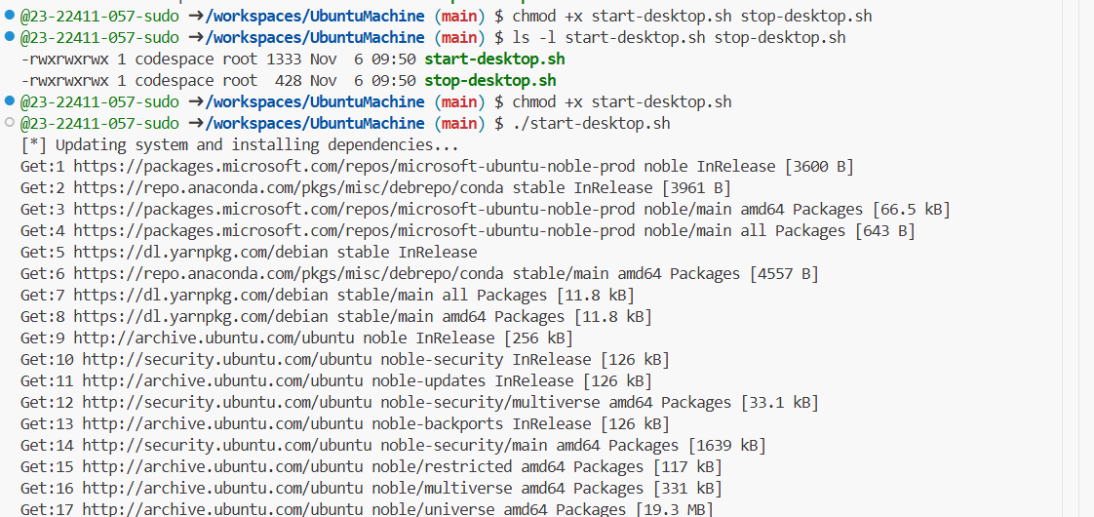
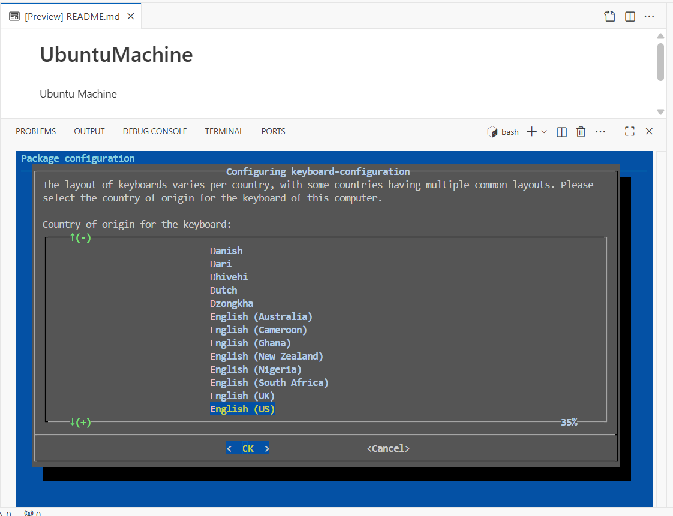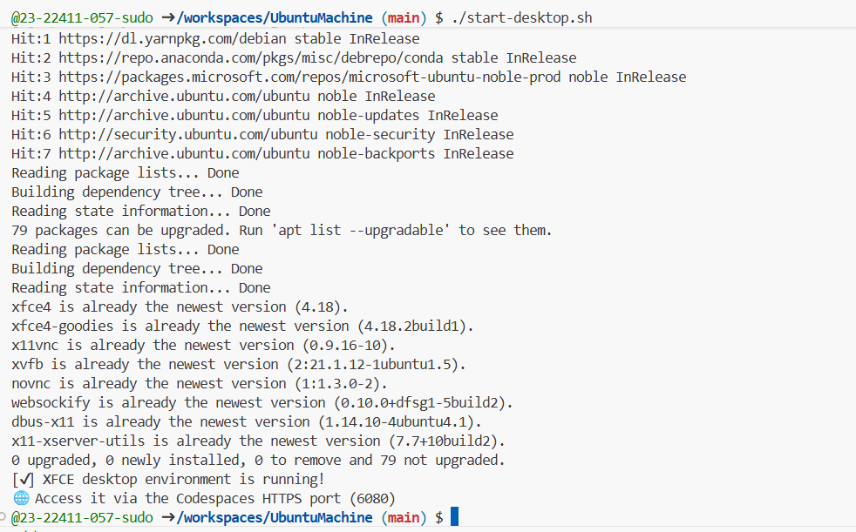
- Verify forwarded ports in Codespaces (Ports view)
- Open the Codespaces "Ports" panel / view and confirm port 6080 is forwarded and visible.
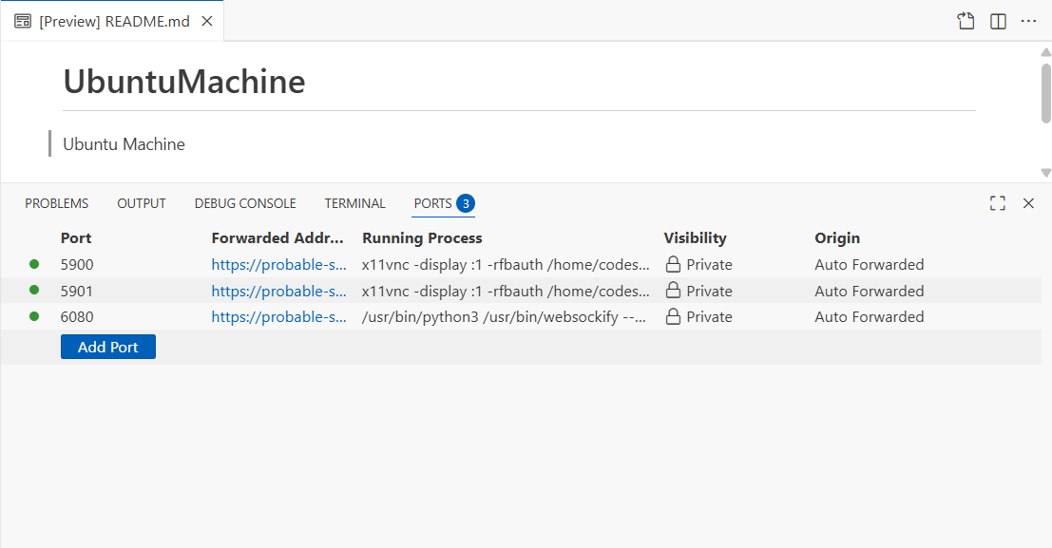
- Open forwarded port 6080 and connect to VNC HTML page
- In the Codespaces UI, open the forwarded port's preview URL or copy the forwarded URL and open it in your browser.
- Visit the port 6080 address and click the vnc.html link.
- When prompted for a password enter:
Codespace
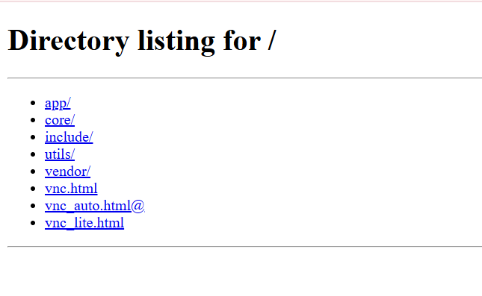
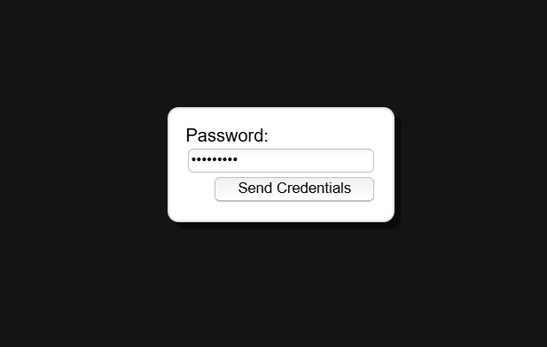

- Stop the GUI
- When finished, return to the Codespace terminal and run:
./stop-desktop.sh
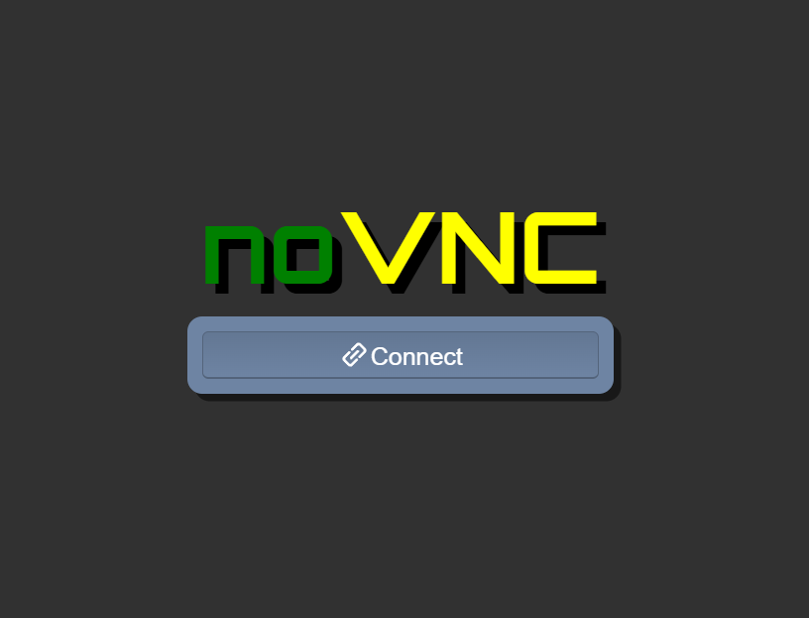
Exam Evaluation Questions
1. Group Management and Membership
Scenario:
Create groups and manage a user’s primary and supplementary group memberships.
Steps:
- Create groups g1, g2, and g3.
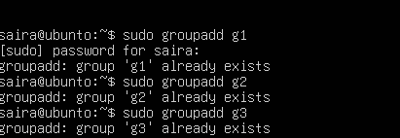
- Change examuser’s primary group to g3 and add g1 and g2 as supplementary groups.

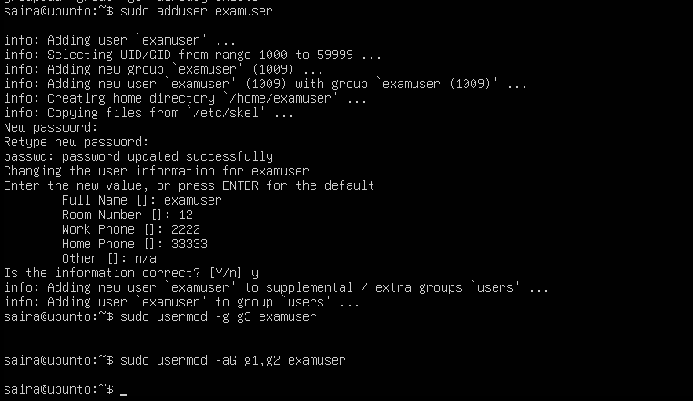
- Show the final id and /etc/group lines that prove the changes.
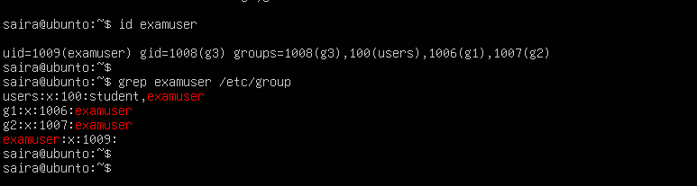
2. Ownership and Permission Tasks
Scenario:
Demonstrate ownership changes and apply both symbolic and numeric permission changes.
Steps:
- Create workspace/secret.txt, change its owner to examuser and group to g1.
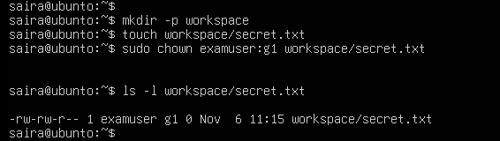
- Remove all permissions for group and others using a symbolic command, then using a numeric command to achieve the same result.
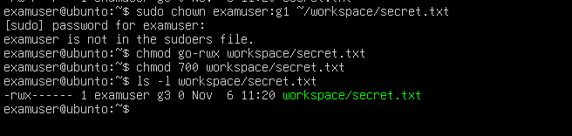
- Show ls -l for the file after each change to document the permission bits.
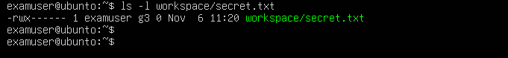
3. Pipes, Grep, and Redirection Practice
Scenario:
Filter system logs and save results using redirection and piping.
Steps:
- Use grep (or journalctl where applicable) with a pipe to find lines containing "error" or "fail" and show the first 20 results.
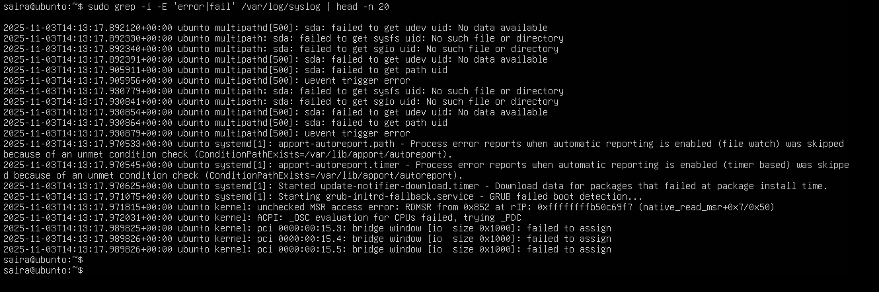
- Save the filtered results to a file ~/logs/errors.txt using overwrite, then append additional matching lines using append redirection.
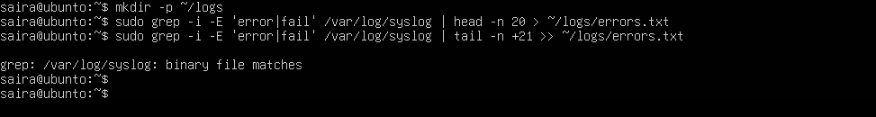
- Use a pager to view the saved file.
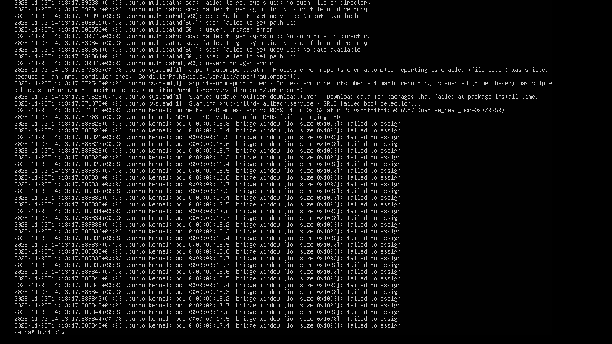
4. Script: Variables, Command Substitution, File & Dir Checks
Scenario:
Build and run a script incrementally that demonstrates variables, command substitution, and filesystem checks.
Steps:
- Create setup.sh with a shebang and a variable var1 that you echo.
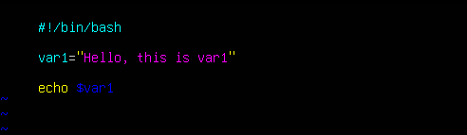
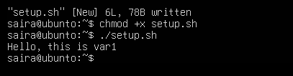
- Append command substitution that stores ls -l output into a variable and echo it.
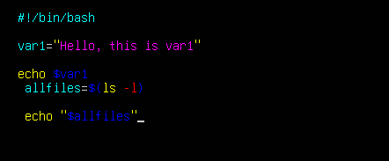
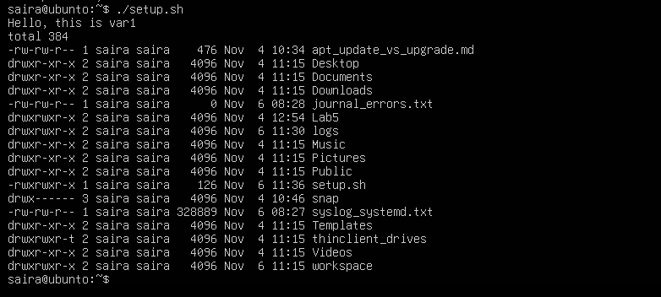
- Append directory and file checks that create dir1 and dir1/file2 if missing, and display their final permissions.
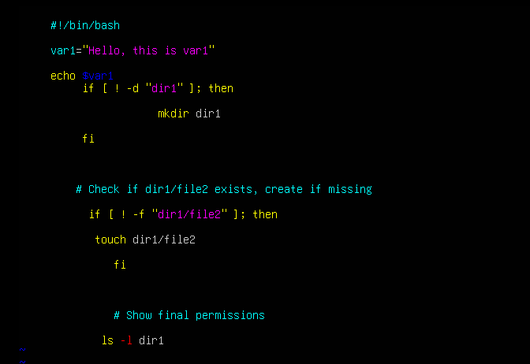
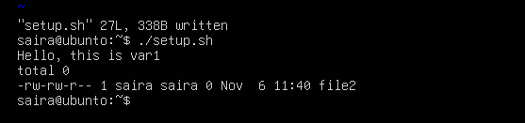
5. Script: Comparisons and String Tests
Scenario:
Incrementally add numeric and string comparison tests to a script and show both true/false cases.
Steps:
- Overwrite setup.sh to set num=$1 and str=$2, and add an -eq test showing true and false examples.
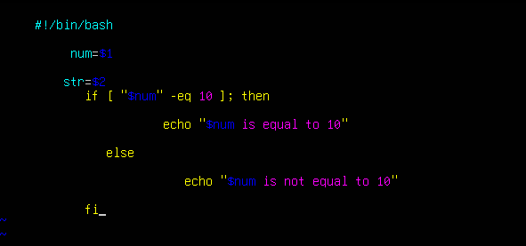
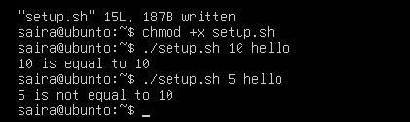
- Append -ne, -gt, -lt, -ge, and -le tests and demonstrate at least one true and one false invocation for each.
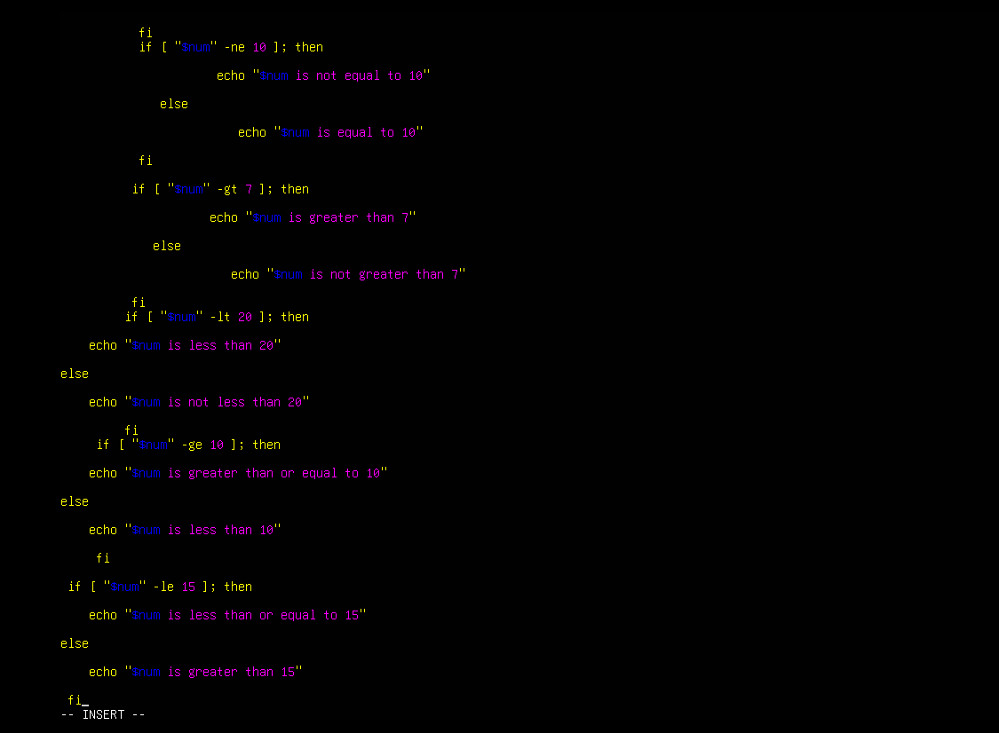
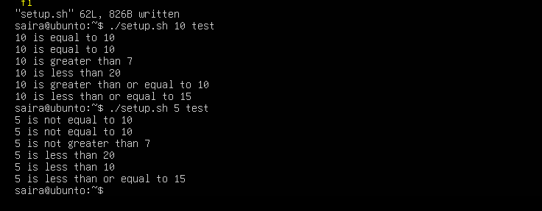
- Append string equality (=) and inequality (!=) checks and a -z (zero-length) test for the second argument, demonstrating true/false cases.
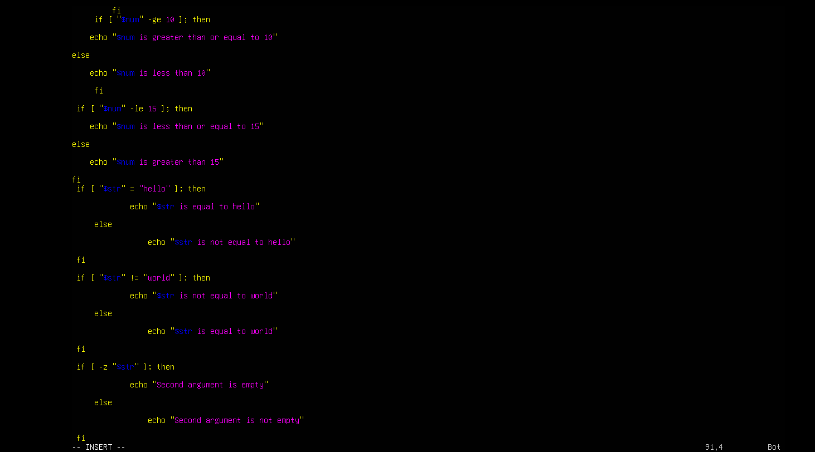
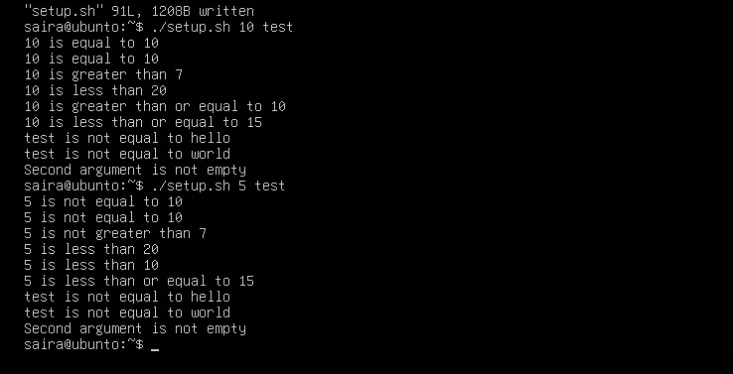
6. Script: For Loop and Argument Handling
Scenario:
Write a script that prints all provided arguments and demonstrate correct handling of quoted multi-word arguments.
Steps:
- Create/overwrite setup.sh to print every argument using "$@" in a for loop and save the file.
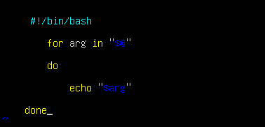
- Run the script with mixed single and quoted multi-word arguments and capture the output showing each argument on its own line.
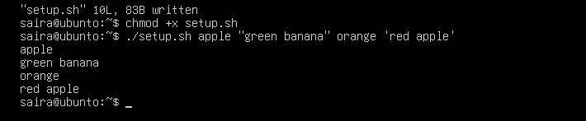
7. Script: While Loop Summation and Functions
Scenario:
Implement an interactive or non-interactive summation function and a demonstrated function that returns a numeric result.
Steps:
- Write an interactive while-loop that accumulates numbers until q is entered and shows running totals.
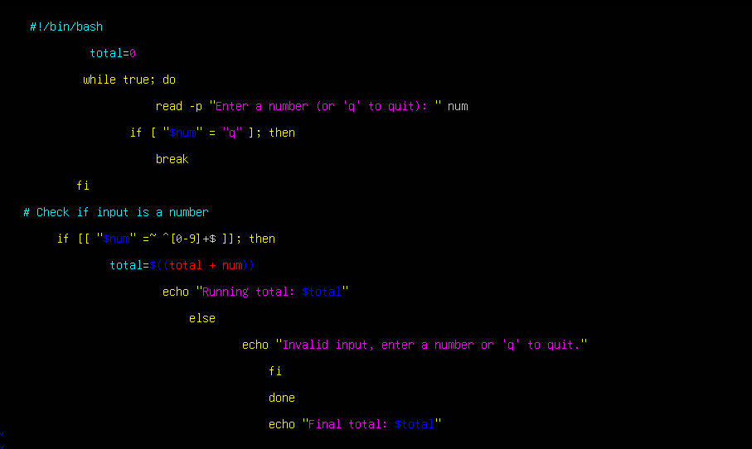
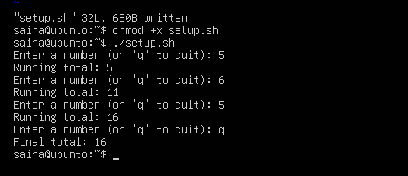
- Add a function that accepts two numeric arguments, returns their sum, and demonstrate capturing its result in a variable.
